**Dealing with Scatter correction for LAI measurements on very sunny or cloudy day.**

**By Gabriel Mulero**

*After collecting LAI measurements with LI2200c, and you have each LAI measurement of your sample or plot or repitition having a SCATTER file, this is how to work with it to implement the scattering factor (K) to your LAI measurements.*

**First:** Import all the files > click **Scattering** on tool bar (Scattering Correction Input Tool interface opens up)

**2.** On **K Records** of the correction interface, choose **Make K from sequence**

**3.** Insert the correct View cap used in **'A' View Cap** box (NB: if using the 10 degree angle View Cap, write it in it because it is not on the list of View Cap in the drop down). If you need to change the **'A' view Direction** please do, if not leave as North (0).

**4.** Select all scatter file (most times taken as **AAAA**) that will give the K factor we need for correcting out LAI measurements for each group.

**5.** Then click on **Make K Records in Checked** (i.e. selected) **Files**.

Notice that the **SCATT** as I named them is not having any K yet **(Fig. 1)**, once we click on the **Make K Records in Checked Files**, all SCATT would immediately have K generated for them (**Fig. 2)**.

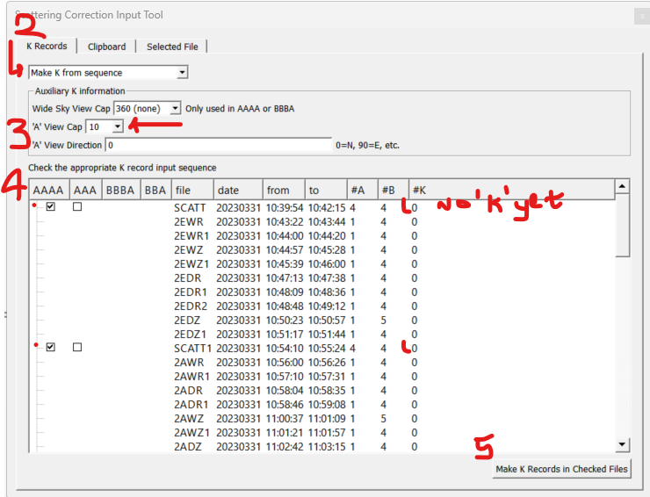

**Figure 1:** Before generating K from the SCATT files

This Ks is what you would give each corresponding or following LAI measurements taken. How do we proceed from here, See **Fig. 2**

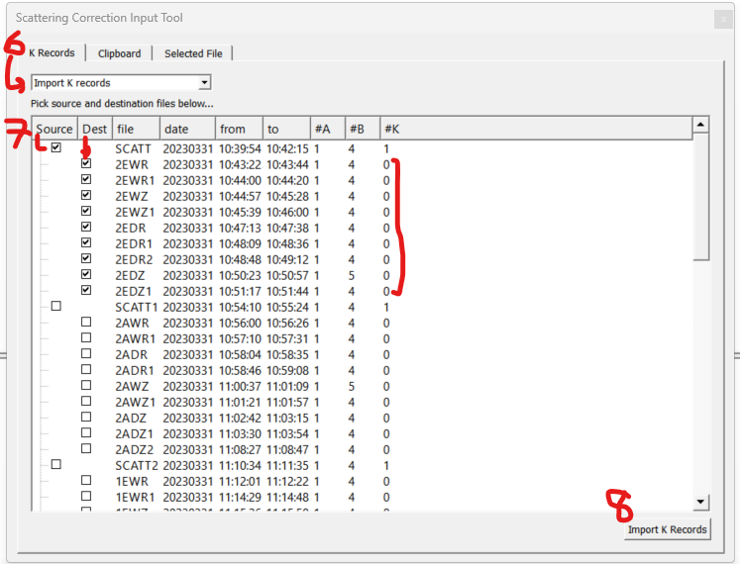

**Figure 2:** After generating SCATT K, and now importing the K record for the corresponding LAI needing it.

**6.** After generating K for each SCATT, on the **K Records** choose **Import K records** next.

**7.** I strongly advise you do each group one after the other, just to erase doubts. Click a **Source**, that is, the SCATT having the K value, and its corresponding LAI needing the K values (the Destination – **Dest**). (Notice that all the LAI measurements do not have K values yet, hence zero).

**8.** Click on **Import K Records**. Once this is done all zeros in under K turns to 1.

**NB**: Repeat 7 & 8 for all other SCATT and its corresponding LAI measurement. Make sure to uncheck the previous Source so it doesn’t interfere with the new import.

**9.** Once done with Importing K Records, Click on **Clipboard** on the Correction interface, maintain all the setting as in **Fig. 3**. Notice, that the **Update Selected Scatter-Corrected Files** tab is not active for clicking. This is because we have not selected any file to Update in the main FV2200 software interface.

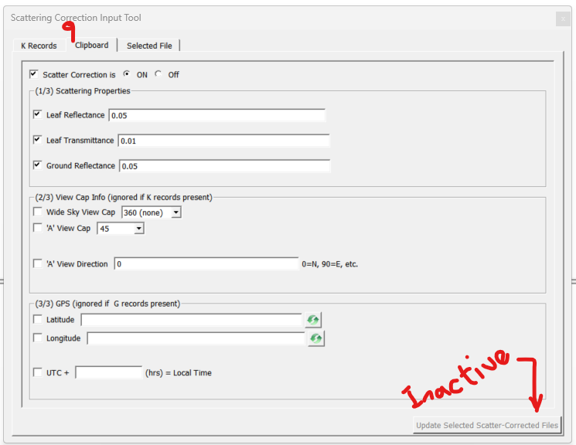

**Figure 3:** Clipboard interface for updating the files to be corrected.

**10.** To make the tab active, go to the main software interface and select all the file needing updating for the correction of the LAI measurements (See blue highlight in **Fig. 4**). Also, under **Records**, you will see **1A 4B 1K** etc., the 1K was updated during the K record generation.

Notice that **none** is shown under **ScattCorr** in main interface, the correction factor will be shown once we click on the now active **Update Selected Scatter-Corrected Files** tab (See **Fig. 5** for changes in **ScattCorr** and **LAI** values).

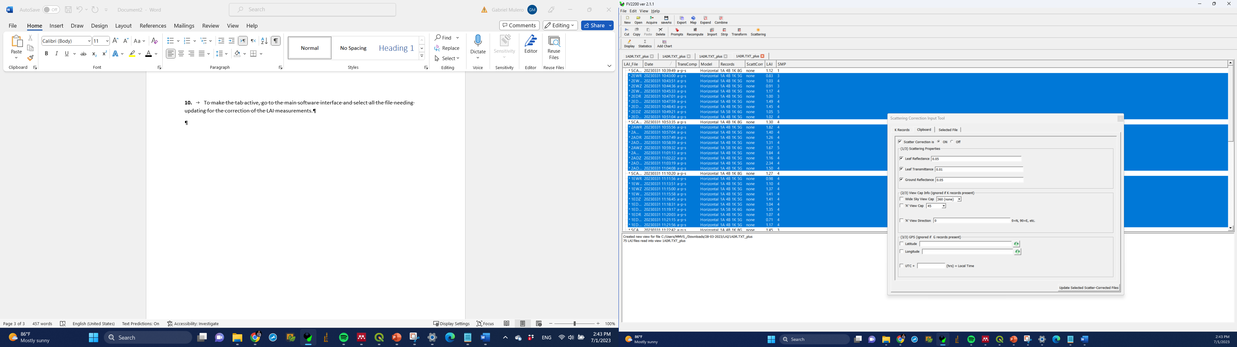

active

**Figure 4**: Showing selected files to correct, and the active **Update** **Selected Scatter-Corrected Files** tab after selecting them.

**11.** Click on Update ……… See result in **Fig. 5** of corrected LAI values. After this you can go ahead to export you files as CSV.

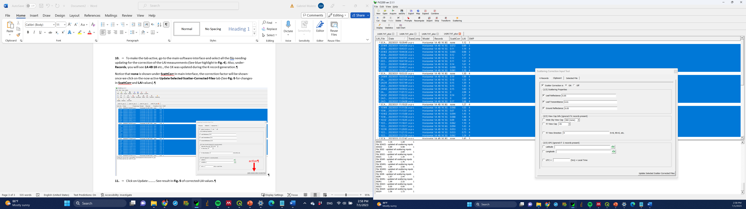

**Figure 5**: After updating all LAI values for the selected changes based on the ScattCorr generated.